Learn the Dom

<https://www.youtube.com/watch?v=y17RuWkWdn8>

# Link to a script file

To start out with one of the most important things is to make sure that your html file is linked to a script file.

to link to a script file, we use the word script in angle braces. Then we shorten the word source to just 3 letters.

**src**

we use an equal sign and inside quotation marks we use the name of the script file with the extension of **.js**

defer: after the script file, you will see the word defer-

If the **defer** attribute is set, it specifies that the **script** is downloaded in parallel to analyzing or (parsing) the page, and executed after the page has finished analyzing (parsing).

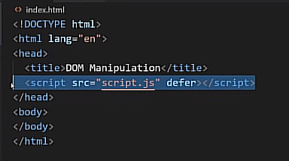

The script file

You will now need to create a script file.

Inside of Visual Studio Code:

New file

Name your new file

script.js

# Messing with the body of the document

if we create a constant, it is a type of variable that cannot be messed with. Which means it does not change like a regular variable does. This means that, and it always means that. So, we are going to create a constant called body and set it to something, and that something is what body will always mean in this document. Because we said so.

Append: append is the method that we use to add elements to the body. So, every time we say the word append, we are adding something to the body. With using just append, we can append a string. There is also append child, but lets just use the append method to print something into our document where we can view it.

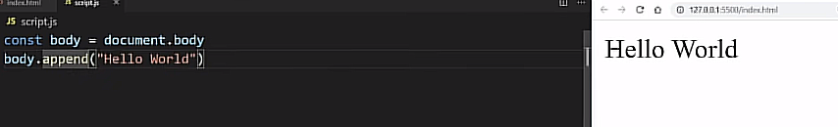

Start here

